*Strategies for a Spectrum of Learners*

A spectrum includes an extensive, colorful, and diverse scale. This applies to rainbows, classrooms, and professional development. The Regional Training Center (RTC) offers a spectrum of courses, given by a spectrum of instructors, to benefit a spectrum of learners!

Educators, administrators, and related service providers, along with beginning and veteran teachers compose a spectrum of educational professionals who register for Regional Training Center’s courses. Registration is now open for the newest RTC course, *Strategies for a Spectrum of Learners* (SSL).

Classrooms include students with above, below, or what is considered to be average skills. Students with ADHD, autism, learning and intellectual disabilities, emotional, social, and behavioral differences, sensory and communication impairments, physical differences, other health impairments, and twice-exceptional learners are just a few of the learners who compose the classroom spectrum. In this age of new teacher evaluations, linked to performances on assessments that are related to Common Core State Standards, educators require a spectrum of strategies. Each student has differing motivation, background knowledge, home and school supports, and an array of performance levels. IEP and 504 driven accommodations are also often required.

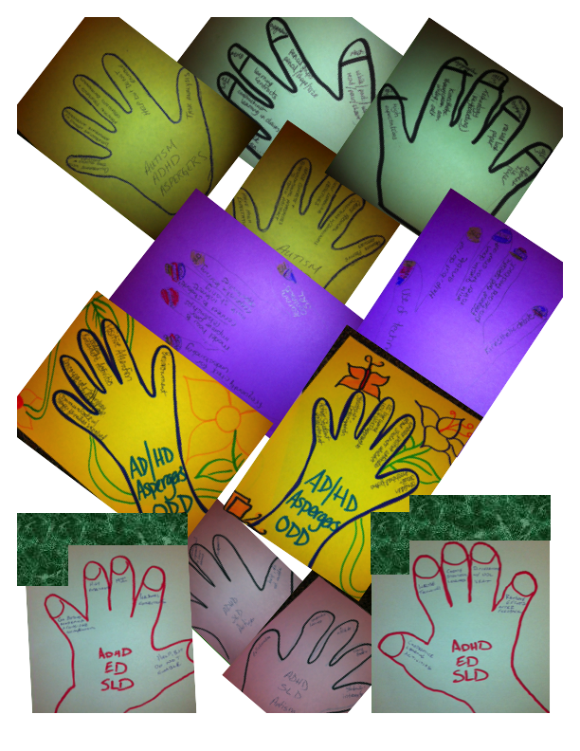The spectrum of diverse learners that exists in our schools requires that teachers be prepared to provide instruction that embraces the individual ability levels of all learners. This course outlines the obstacles that are presented, but at the same time acknowledges the spectrum of strategies that help educators to achieve the nonnegotiable successful outcomes!

These pictures depict active *hands-on* engagement that the SSL course provides. You are invited to register for the course and experience it *first-hand* in Mahwah, NJ on July 22-24, 29-30. It will be offered again in the Fall in September and October in Langhorne, Pennsylvania and in November in Randolph, New Jersey. This [RTC link](https://www.thertc.net/classes.php?course=2945) offers more information.